

A

Project Report
on
LegalEase: An AI-Powered Legal Document Summarization and Risk Analysis System
submitted as partial fulfillment for the award of

BACHELOR OF TECHNOLOGY
DEGREE
SESSION 2025-26
in
Computer Science and Engineering
By
Harsh Kumar Singh (2200290100073) Prasoon Krishna Gupta (2200290100119) Om Vrit Chitrada (2200290100112) Piyush Raj (2200290100114)

Under the supervision of
Mr. Saurav Chandra (Assistant Professor)
KIET Group of Institutions, Ghaziabad
Affiliated to

Dr. A.P.J. Abdul Kalam Technical University, Lucknow

(Formerly UPTU)
May, 2026

DECLARATION

We hereby declare that this submission is our own work and that, to the best of our knowledge and belief, it contains no material previously published or written by another person nor material which to a substantial extent has been accepted for the award of any other degree or diploma of the university or other institute of higher learning, except where due acknowledgment has been made in the text.

Signature: Signature:

Name: Harsh Kumar Singh Name: Prasoon Krishna Gupta

Roll No.: 2200290100073 Roll No.: 2200290100119

Date: Date:

Signature: Signature:

Name: Om Vrit Chitrada Name: Piyush Raj
Roll No.: 2200290100112 Roll No.: 2200290100114

Date: Date:

CERTIFICATE

This is to certify that Project Report entitled LegalEase which is submitted by Harsh Kumar Singh, Prasoon Krishna Gupta, Om Vrit Chitrada, Piyush Raj in partial fulfillment of the requirement for the award of degree B. Tech. in Department of Computer Science & Engineering of Dr. A.P.J. Abdul Kalam Technical University, Lucknow is a record of the candidates own work carried out by them under my supervision. The matter embodied in this report is original and has not been submitted for the award of any other degree.

Saurav Chandra Dr.Vineet Sharma

(Assistant Professor) (Dean CSE)

Date:

ACKNOWLEDGEMENT

It gives us a great sense of pleasure to present the report of the B. Tech Project undertaken during
B. Tech. Final Year. We owe special debt of gratitude to Mr. Saurav Chandra, Department of Computer Science & Engineering, KIET, Ghaziabad, for his constant support and guidance throughout the course of our work. His sincerity, thoroughness and perseverance have been a constant source of inspiration for us. It is only his cognizant efforts that our endeavors have seen light of the day.
We also take the opportunity to acknowledge the contribution of Dr. Vineet Sharma, Dean of the Department of Computer Science & Engineering, KIET, Ghaziabad, for his full support and assistance during the development of the project. We also do not like to miss the opportunity to acknowledge the contribution of all the faculty members of the department for their kind assistance and cooperation during the development of our project.
We also do not like to miss the opportunity to acknowledge the contribution of all faculty members, especially Mr. Saurav Chandra, of the department for their kind assistance and cooperation during the development of our project. Last but not the least, we acknowledge our friends for their contribution in the completion of the project.
Date: Signature

Harsh Kumar Singh (2200290100073) Prasoon Krishna Gupta (2200290100119) Om Vrit Chitrada (2200290100112) Piyush Raj (2200290100114)

ABSTRACT

Legal documents such as contracts, agreements, and compliance filings are inherently complex, often written in specialized language that is difficult for non-experts to interpret. Manual review of such documents is time-consuming, costly, and prone to human error, creating a need for automated and intelligent analysis systems.

This project presents LegalEase, an AI-powered legal document analysis system designed to simplify and enhance contract understanding through automation. The system integrates a domain-adapted transformer model with a hybrid rule–machine learning architecture to perform clause classification, vulnerability detection, and risk assessment. It accepts unstructured documents in multiple formats, applies layout-preserving OCR, segments text into meaningful legal units, and extracts key entities and clauses.

LegalEase further identifies potential risks and vulnerabilities within documents and generates plain-language explanations along with actionable recommendations. A risk scoring mechanism aggregates clause-level findings into an overall contract risk rating, enabling users without legal expertise to make informed decisions.
The proposed system emphasizes explainability by highlighting evidence spans and providing reasoning for detected risks. Experimental evaluation demonstrates strong performance in clause classification and effective detection of high-risk vulnerabilities, making the system both practical and reliable.

Overall, LegalEase offers a scalable, interpretable, and efficient solution for automated legal document analysis, reducing dependency on expert review while improving accuracy, accessibility, and decision support in legal workflows.

TABLE OF CONTENTS Page No.

DECLARATION ii
CERTIFICATE iii
ACKNOWLEDGEMENTS iv
ABSTRACT v
LIST OF FIGURES ix
LIST OF TABLES xi
LIST OF ABBREVIATIONS xii
CHAPTER 1 (INTRODUCTION) 1
  - Background of the study 1
  - Need for Automated Legal Analysis 2
  - Problem Statement 2
  - Objectives of the Project 3
  - Scope of the Project 3
  - Organization of the Report 4
CHAPTER 2 (LITERATURE REVIEW) 7
  - Overview of Legal NLP 7
  - Evolution of AI in the Legal Domain 8
  - Existing Legal AI Systems 9
  - Techniques in Legal Document Processing 10
  - Research Gaps 11
CHAPTER 3 (PROPOSED METHODOLOGY) 12
  - System Overview 12
  - System Architecture 13
  - Document Processing Pipeline 13
  - Clause Classification 14
  - Risk Detection Mechanism 15
  - Evaluation Metrics 16
  - Summary of Methodology 17
CHAPTER 4 (IMPLEMENTATION) 18
  - Implementation Overview 18
  - Technology Stack 19
  - Backend Implementation 20
  - NLP Pipeline Implementation 21
  - Clause Classification Implementation 22
  - Risk Detection Implementation 23
  - Integration of System Components 24
CHAPTER 5 (RESULTS AND DISCUSSION) 25
  - Overview of Evaluation 25
  - Clause Classification Performance 26
  - Vulnerability Detection Results 27
  - Impact Analysis: Reduction in Undetected Risks 28
  - Summarization Performance 29
  - Comparative Analysis 30
CHAPTER 6 (CONCLUSIONS AND FUTURE SCOPE) 31
  - Conclusion 32
  - Future Scope 33
REFERENCES 35
APPENDIX 1 36

LIST OF FIGURES

Figure No. Description Page No.
  - LegalEase Document Processing Pipeline 12
  - LegalEase System Architecture 13
  - LegalEase System Workflow 14
  - Model Performance Comparison graph 25
  - Reduction in undetected risks 27

LIST OF TABLES
Table. No. Description Page No.
2.1 Comparative Study of Legal Document Analysis 11
4.1 Technology Stack Used in LegalEase System 20
5.1 Model Performance Comparison 30

LIST OF ABBREVIATIONS

AI | Artificial Intelligence
NLP | Natural Language Processing
ML | Machine Learning
OCR | Optical Character Recognition
NER | Named Entity Recognition
LLM | Large Language Model
API | Application Programming Interface
UI | User Interface
PDF | Portable Document Format
POS | Part-of-Speech
BERT | Bidirectional Encoder Representations from Transformers
RNN | Recurrent Neural Network
SVM | Support Vector Machine
RF | Random Forest
XGBoost | Extreme Gradient Boosting
F1 | F1 Score
TP | True Positive
FP | False Positive
FN | False Negative
ROUGE | Recall-Oriented Understudy for Gisting Evaluation

CHAPTER 1 INTRODUCTION

Background of the study

Legal documents represent the core of any business interactions, governance, and regulation nowadays. Contracts, agreements, memos, policies, filings—these documents regulate what is owed, what actions are allowed, and whose rights and obligations may have implications if certain scenarios occur. They range from simple agreements between two businesses to complex multilateral agreements and regulatory filings with various purposes and different degrees of intricacy and complexity. Nevertheless, these documents are usually written in an incomprehensible style using specialized terminology, long complex sentences, and nested conditional structures that may not be easily interpreted by those unfamiliar with legal documents.
For centuries, writing of such documents was valued above all by its precision and exhaustiveness but rarely paid attention to its readability. These documents use archaic terms, Latin, negative phrasing, frequent cross-references, and ambivalent pronouns. Long sentences with several conditions and exceptions follow one another and are required to be thoroughly parsed to capture the entire meaning. For laymen, legal documents are difficult to understand, leading to overlooking potentially detrimental terms and conditions.
Traditionally, reviewing legal documents is conducted manually by contract lawyers, paralegals, and compliance officers. Such approaches provide professional evaluation but are very slow, expensive, and subject to human error, especially for larger numbers of documents and tight deadlines. In rapidly evolving industries, such as finance, technology, manufacturing, and retail, hundreds to thousands of contracts are made yearly, and each contains several clauses to examine and evaluate.
Furthermore, today's legal landscape is becoming increasingly complex due to international and regional differences in legal norms. Multijurisdictional entities have to operate within different

national and sectorial laws and standards. The risk of overlooking some clause is great, and the consequences of doing so might include costly and damaging penalties.
Developments in Artificial Intelligence (AI) and Natural Language Processing (NLP) technologies make it possible to apply advanced language models to the task. AI and NLP enable processing and generation of natural language documents efficiently and in vast quantities. However, applying these models to legal documents requires special consideration because their structure and linguistic characteristics distinguish legal documents from common texts or other professional texts. The need for extreme accuracy and interpretability also cannot be underestimated.

This project seeks to solve such a practical problem that is present in many modern corporations and agencies—automating legal document analysis. LegalEase aims to develop a solution based on current progress in NLP and tailored to the specifics of legal texts

Need for Automated Legal Analysis
The increasing volume of legal documentation, combined with its growing complexity, demands more efficient solutions than traditional manual review methods. In today’s fast-paced and highly competitive business environment, contracts and agreements must be reviewed, negotiated, and finalized within tight deadlines. Relying solely on manual processes can lead to significant delays, which in turn may result in missed business opportunities, financial losses, or even non-compliance with regulatory requirements. As organizations scale, the burden of handling extensive legal documentation only intensifies, making automation an essential necessity rather than a luxury.

Another critical concern is the cost associated with legal expertise. Many small and medium-sized enterprises (SMEs) do not have dedicated legal teams and are often required to outsource legal services at high costs. This dependence not only increases operational expenses but also creates bottlenecks in decision-making processes. Automated legal analysis tools can help bridge this gap by providing affordable and scalable solutions, enabling organizations of all sizes to efficiently manage their legal documentation without incurring excessive costs.

Human error is also a significant factor that highlights the need for automation. Even experienced legal professionals can overlook important clauses or misinterpret certain terms due to fatigue, time pressure, or the sheer volume of documents. Such errors can have serious consequences, including contractual disputes, financial liabilities, or reputational damage. Automated systems, in contrast, are capable of consistently analyzing large datasets with precision, ensuring that critical details are not missed and reducing the overall risk of oversight.

In addition to accuracy, speed plays a crucial role in modern legal workflows. Automated systems can process and analyze documents in a fraction of the time required for manual review. This acceleration allows organizations to make quicker decisions, respond promptly to business opportunities, and maintain a competitive edge. Faster processing also enables real-time insights, which are particularly valuable in dynamic environments where legal requirements and business conditions are constantly evolving.

Accessibility is another important dimension driving the adoption of automated legal analysis. Legal documents are often written in complex language that is difficult for non-experts to understand. This creates a barrier for individuals and businesses who need to interpret such documents but lack formal legal training. Automated tools can simplify legal language, highlight key clauses, and provide clear summaries, thereby making legal information more accessible and actionable for a broader audience.

Problem Statement

Even with the variety of software and tools available for text processing and document analysis, current methods of analyzing legal documents still fall short in dealing with the intricate nature of legal language. Keyword searches tend to ignore the broader context and fail to reveal hidden connections between the clauses in a document. Thus, they might overlook potential weaknesses or give an inaccurate interpretation.

Furthermore, manual review is inefficient when it comes to scaling up operations. With the increasing number of documents, purely manual inspection becomes untenable. Manual review results in delayed output, high cost, and unreliable analysis. In addition, modern AI tends to solve separate tasks, such as summarization or classification, without offering an integrated end-to-end solution to legal document analysis.

There is a growing trend toward explainable AI, particularly in the field of law. In law, decisions require transparency and justification. However, many sophisticated models act as black boxes that provide little insight into how the decision was made.

Objectives of the Project

This paper will attempt to build a smart system capable of automating legal document analysis while ensuring high levels of precision, clarity, and usability. Such system will be able to perform multiple functions seamlessly: classifying clauses, detecting vulnerabilities, and assessing risks within the same process flow.
One of the key goals set out for the project includes making its output comprehensible for non-experts via the usage of layman’s language. Namely, that implies producing summaries and explanations of legal documents while retaining their meaning. The project also foresees introducing the element of risk assessment that would provide users with an overview of the potential danger posed by the document in question.

As far as system design goes, the idea behind creating a modular framework was chosen since that approach is flexible enough to work with various types of documents and their purposes. A good combination of machine learning algorithms and rules could be achieved here.

Scope of the Project

The objective of this project is to develop a system that can efficiently process different types of legal documents, such as contracts, agreements, and compliance reports. Legal documents often come in varied formats, including both digitally created files and those that have been manually converted into digital form. The system is designed to handle this diversity and work

effectively across different document structures. A key goal is to extract meaningful information from unstructured legal text, making it easier to understand and work with, while also improving the overall efficiency of document handling

Another important aim of the system is to support the analysis of legal documents by identifying important clauses, terms, and relevant patterns within the text. Instead of requiring users to manually go through lengthy documents, the system helps by highlighting key information and presenting it in a more accessible way. This reduces the time and effort needed for routine document review and allows users to focus more on critical thinking and decision-making tasks. In this way, the system acts as a practical tool to improve productivity and streamline legal workflows.

At the same time, it is important to recognize the limitations of the system. It is not designed to replace lawyers or make legal decisions on their behalf. Rather, it serves as a supportive tool that assists in analyzing documents and organizing information. The responsibility for interpreting legal content and making final decisions remains with legal professionals. By focusing on assisting rather than replacing, the system aims to enhance existing processes while respecting the importance of human expertise in the legal domain.

Organization of the Report

The primary objective of this report is to present a comprehensive and structured overview of the proposed system, its design, and its implementation. The report begins with an introduction that outlines the background of the problem, highlighting the challenges associated with analyzing complex legal documents. It further defines the problem statement, research objectives, and the overall scope of the project, establishing the motivation behind the development of the system.
Following this, a detailed review of existing literature and relevant technologies is presented. This section examines prior work in the domains of legal natural language processing, document

intelligence, and automated risk detection, providing a foundation for understanding the current state of research and identifying existing gaps that the proposed system aims to address.
Subsequently, the implementation section details the practical aspects of system development, including the tools, frameworks, and technologies used. It highlights the integration of machine learning models, rule-based mechanisms, and supporting technologies that enable efficient and scalable processing of legal documents.
The report further presents the experimental results obtained from the evaluation of the system, accompanied by a detailed discussion of the findings. This includes an analysis of performance metrics, comparison with baseline approaches, and insights into the effectiveness of the proposed solution.
Finally, the report concludes with a discussion of the broader implications of the research, emphasizing its potential applications in real-world scenarios. It also outlines limitations of the current system and suggests directions for future work, thereby providing a complete and holistic view of the research contribution.

CHAPTER 2 LITERATURE REVIEW

Overview of Legal NLP

Legal Natural Language Processing is a specialized subset of NLP that focuses on parsing and understanding legal text. Unlike general-purpose text processing, legal NLP must handle domain-specific terminology, complex sentence structures, and relationships that may span multiple sections within a document. Legal texts often include nested clauses, cross-references, and implicit meanings, which require more advanced and context-aware modeling techniques.
As the field has evolved, legal NLP now covers a wide range of tasks, including clause detection, entity recognition, document classification, and even aspects of legal reasoning. The shared goal of these processes is to convert unstructured legal content into structured data that can be efficiently analyzed and interpreted. However, achieving high levels of accuracy remains challenging due to the ambiguity and intricacy of legal language.
Another important aspect of legal NLP is the need to preserve contextual integrity while processing text. Unlike simpler domains, where sentences can often be analyzed independently, legal documents require models to consider broader context across paragraphs or even the entire document. Misinterpreting a single clause or reference can lead to incorrect conclusions, making it essential for systems to maintain a high level of contextual awareness. This further increases the complexity of designing reliable and effective legal NLP solutions.

Evolution of AI in the Legal Domain

AI applications in the field of law have made remarkable progress throughout the years. Initially, the systems relied on rule-based techniques, employing predefined patterns and logic to identify particular elements within texts. Such an approach was rather successful when dealing with straightforward tasks, yet it had limitations in terms of adaptability and lack of flexibility in adjusting to changing legal frameworks.

Next came machine learning and brought with itself a number of advantages. Approaches like Support Vector Machines and Random Forests were successfully applied in such processes as document classification and entity recognition. However, even machine learning algorithms suffered from the need to define numerous parameters manually and lack of contextual understanding.
A breakthrough occurred with the development of transformer-based models, which brought an unprecedented level of comprehension to natural language processing. The effectiveness of algorithms like BERT and its adaptations specifically aimed at legal texts is evident in classification and analysis. Nevertheless, there are persistent issues in terms of interpretability and availability of relevant data.

Existing Legal AI Systems

Various automation approaches have been proposed for legal document analysis, including contract analysis tools, legal research platforms, and document summarization systems. While these solutions offer significant benefits, most of them are designed to perform a single specific task rather than providing a comprehensive approach to document analysis. As a result, users often need to rely on multiple tools to fully understand a legal document, which can be inefficient and time-consuming.
For example, document summarization systems are effective in generating concise versions of lengthy legal texts, but they generally do not address critical aspects such as risk assessment or the identification of potential weaknesses within the document. Similarly, some systems excel at entity extraction, identifying key elements like names, dates, or organizations, but fail to capture the relationships and dependencies between different clauses. Another major limitation observed in many existing systems is the lack of transparency, where users are not provided with clear explanations of how conclusions or outputs are generated.
Additionally, many of these tools struggle with adaptability and domain-specific variations in legal language. Legal documents can differ significantly across jurisdictions, industries, and use cases, making it challenging for one-dimensional systems to perform consistently well. Without the ability to integrate multiple analytical capabilities or adjust to different contexts, these

solutions often fall short in meeting real-world requirements. This highlights the need for more integrated and flexible systems that can combine multiple functionalities—such as summarization, classification, and risk analysis—into a single, cohesive framework..

Techniques in Legal Document Processing

When you're dealing with legal documents, the journey from a pile of papers to usable information starts with getting the text out of those documents in the first place. If you're working with scanned PDFs or physical documents, optical character recognition (OCR) technology does the heavy lifting, converting images into actual readable text. Once you've got the raw text, preprocessing becomes essential—and honestly, it's where a lot of the grunt work happens. You'll need to break the text down into manageable chunks through tokenization, clean it up via normalization to ensure consistency, and segment it logically so the system can actually make sense of what it's reading. This foundational work might not be glamorous, but it's absolutely critical because garbage in means garbage out.
The real value starts emerging when you begin understanding what's actually in these documents. Legal agreements are essentially collections of clauses, each serving a specific purpose—whether it's defining liability, outlining payment terms, or establishing obligations. Identifying and categorizing these clauses is where the meaningful analysis happens. Beyond just finding clauses, you need to extract the key entities that matter: who are the parties involved, what are the important dates, and what are the financial figures at stake? Modern approaches lean heavily on transformer-based models like BERT and GPT variants, which excel at capturing the nuanced relationships between words and understanding context in ways that simpler pattern-matching couldn't. These sophisticated models can grasp that "termination" might mean something different in one clause versus another, depending on the surrounding context.
In practice, the most effective systems don't rely solely on machine learning or just rules—they use a combination of both. You might have rule-based logic that quickly identifies standard contract sections and clauses based on predictable patterns, while machine learning handles the more complex interpretive work where context really matters. This hybrid approach has become the industry standard because it gives you the best of both worlds: the speed and predictability

of rules, combined with the flexibility and accuracy of modern AI. It's not about choosing one technology over the other, but rather orchestrating them smartly so that each tackles what it does best, resulting in faster processing times and fewer errors that would otherwise need manual review

2.5 Research Gaps

Despite the significant progress made in applying AI to legal workflows, several important gaps still remain. One of the primary challenges is the lack of fully integrated end-to-end systems that can address multiple requirements at once. Most existing solutions focus on optimizing individual tasks, such as summarization or classification, rather than providing a complete and seamless workflow. This limits their effectiveness in real-world scenarios where multiple types of analysis are needed together.
Another issue is the limited availability of high-quality training data. Legal documents are often sensitive and confidential, which makes them difficult to use for training and evaluation. As a result, models may be trained on restricted datasets, affecting their accuracy and performance. In addition, many systems struggle to generalize across different domains, document formats, and jurisdictions, which reduces their practical usability.
Explainability is also an important concern. Legal professionals need to clearly understand how a system arrives at its conclusions in order to trust and use it effectively. Without transparency in decision-making, even accurate systems may not be widely adopted. Therefore, improving explainability while maintaining performance remains a key challenge in this field.

TABLE 2.1 Comparative Study of Legal Document Analysis Systems

Study / Initiative | Focus Area | Key Findings | Challenges
Kumar et al. | Fraud detection using LLMs | Detects fraud using OCR + LLM pipeline | OCR quality affects results
Springer AI & Law | Decision support systems | Predicts legal outcomes | Bias in training data
ACL NLP  Workshop | Legal NLP tasks | Improves NER & classification | Dataset limitations
IBM Research | Hybrid AI risk detection | Combines ML + rules for accuracy | Rule maintenance difficult
LegalEase | End-to-end analysis | Clause classification + risk detection + explainability | Depends on data quality

CHAPTER 3 PROPOSED METHODOLOGY

System Overview

In order to make the working of LegalEase clearer, below is the high-level view of the legal document analytics workflow. This gives an idea about how each module works with respect to other modules and contributes to the end-to-end process that involves ingestion of documents till the generation of the risk report.

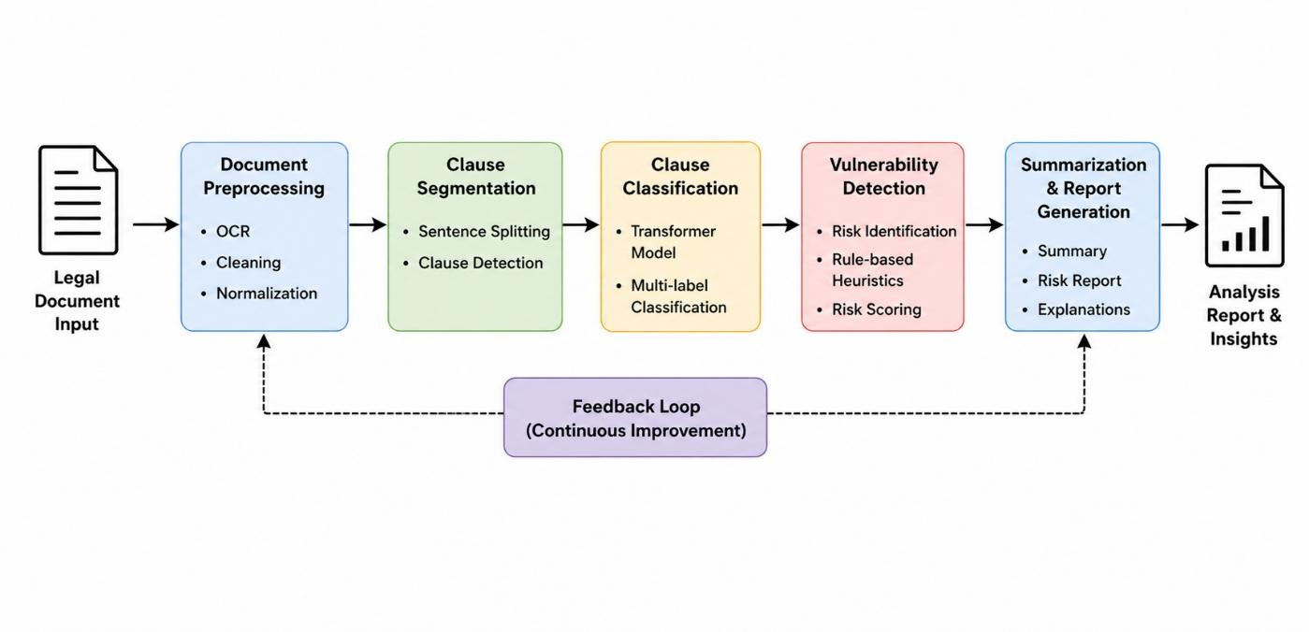

Fig. 3.1 LegalEase document processing pipeline

This figure visually demonstrates how the system integrates document parsing, clause classification, vulnerability detection, and summarization into a cohesive pipeline. It also helps in understanding the interaction between machine learning components and rule-based systems within the architecture.

System Architecture

In order to provide a more accurate representation of the architecture, an architecture diagram has been provided. This illustrates the key components involved and how they relate to each other, including the frontend, backend orchestration, NLP processing modules, and the risk assessment engine. The focus has been placed on the modularity of the solution, whereby each module can work independently but still contribute to the entire process flow.

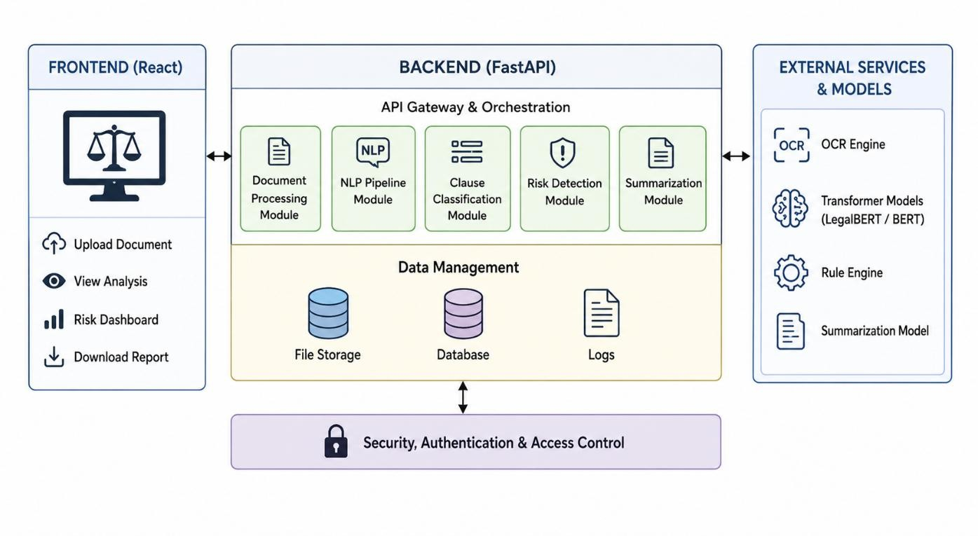

Fig. 3.2 LegalEase Architecture

The architecture diagram illustrates how data flows between different layers of the system, starting from user input to final output generation. It also reflects the hybrid nature of the system, combining deterministic rule-based logic with machine learning models to ensure both accuracy and reliability.

Document Processing Pipeline

The document processing pipeline can be further understood through a workflow diagram that represents the sequential execution of each stage. This workflow captures how raw input documents are transformed into structured outputs through multiple processing steps, including OCR, preprocessing, segmentation, analysis, and summarization.
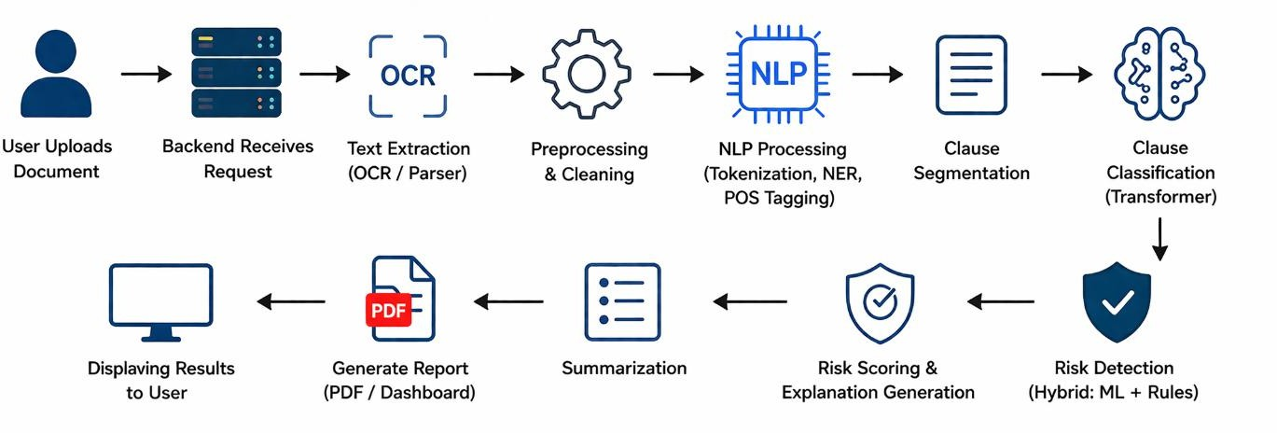

Fig.3.3 LegalEase Workflow

This workflow diagram provides a step-by-step representation of the system’s operation and helps in visualizing how different modules collaborate to produce the final results. It also highlights the efficiency of the pipeline in handling diverse document formats and ensuring consistent processing.

Clause Classification

By comparing clause classification systems and tools along with similar systems and tools, the strengths and weaknesses become apparent. In the context of legal document processing, various researches on how to detect clauses, extract entities, and do legal reasoning are done to see whether the methods work or not. These comparisons are useful to find out which method can be applied in specific circumstances, hence highlighting the reason for designing LegalEase.
As presented in the table above, several researches have been conducted in the field of legal document processing, mentioning their areas of focus, findings, and encountered problems. One can observe that although these systems are making progress in each task, there are very few that provide an integrated approach combining all aspects such as accuracy, explanation, and scalability.

Risk Detection Mechanism

The real test of any risk detection system is whether it can actually perform when it matters most—when you're looking at contracts from different industries, different jurisdictions, and different legal contexts. The beauty of combining rule-based systems with machine learning models is that you get the best of both worlds: rules are excellent at catching known patterns and obvious red flags, while ML models can recognize the subtle, context-dependent risks that would otherwise slip through the cracks. What's particularly important here is that this hybrid approach doesn't sacrifice transparency for accuracy. You can still audit why the system flagged something because part of the decision-making is rule-based and explainable, while the ML component picks up on risks that are harder to articulate as explicit rules. This balance between catching nearly everything and maintaining the ability to explain your findings is what makes teams actually trust the system in practice.
The complexity of legal documents means that risks rarely exist in isolation—they're interconnected through a web of dependencies across different clauses that most traditional approaches completely miss. When you're reading a contract, a seemingly innocent term in one clause might interact dangerously with another clause somewhere else in the document. A standard payment schedule, for instance, could become problematic when combined with certain termination rights, or a warranty clause might conflict with liability limitations elsewhere. By deploying multiple complementary algorithms instead of relying on a single approach, the system can navigate this intricate landscape and identify these interdependencies that humans often spend hours trying to untangle manually. It's like having multiple specialists reviewing the same document—each one brings their own expertise and catches different types of issues that their colleagues might have overlooked.
When you step back and look at the bigger picture, the risk detection module isn't just another feature tacked onto the system—it's genuinely foundational to the whole thing working reliably. Teams depend on these systems to protect them from costly oversights, regulatory violations, and unexpected liabilities that could derail deals or create legal exposure down the line. The confidence you gain from knowing that both transparent rules and sophisticated algorithms are constantly scanning for dangers means you can move faster without sacrificing due diligence.

In today's fast-paced business environment where deals move quickly and document volumes are massive, having a risk detection system that's both comprehensive and trustworthy becomes a competitive advantage. It's the difference between catching problems early when they're still manageable and discovering them after they've become expensive headaches.

Evaluation Metrics

To evaluate the performance of the LegalEase system, several standard metrics are used across different components of the pipeline. These metrics ensure that the system’s outputs are both accurate and reliable.
For clause classification, precision is used to measure the proportion of correctly predicted clauses out of all predicted clauses, while recall measures the proportion of correctly identified clauses out of all actual clauses. The F1-score provides a balance between precision and recall, offering a comprehensive measure of classification performance.
For vulnerability detection, multi-label evaluation metrics are applied since a single clause may contain multiple risks. Micro-F1 is used to evaluate overall detection performance, while Precision@K measures the correctness of top predicted risks.
For summarization, the ROUGE-L metric is used to evaluate the similarity between generated summaries and reference summaries. Additionally, compression ratio is used to measure how effectively the system reduces document length while preserving key information.
Precision = TP / (TP + FP) Recall = TP / (TP + FN)
F1 Score = 2 × (Precision × Recall) / (Precision + Recall)

Summary of Methodology

Combining rule-based systems with machine learning models delivers the best of both worlds: rules catch obvious red flags, while ML models recognize subtle, context-dependent risks that would slip through traditional approaches. This hybrid approach maintains transparency while improving accuracy—you can audit why the system flagged something since the decision-making is partially explainable. More importantly, legal document risks rarely exist in isolation. They're interconnected through dependencies across clauses that traditional approaches miss entirely. A payment schedule might conflict with termination rights, or warranty clauses might contradict liability limitations elsewhere. Multiple complementary algorithms can identify these interdependencies that humans would spend hours untangling manually.
The risk detection module is foundational to system reliability. Teams depend on it to prevent costly oversights, regulatory violations, and unexpected liabilities that derail deals. Knowing that both transparent rules and sophisticated algorithms constantly scan for dangers means you can move faster without sacrificing due diligence. In today's fast-paced environment where deals move quickly and document volumes are massive, a comprehensive and trustworthy risk detection system becomes a genuine competitive advantage. It's the difference between catching problems early and discovering them after they've become expensive headaches.

CHAPTER 4 IMPLEMENTATION

Implementation Overview

LegalEase isn't just a theoretical framework—it's a practical solution designed to bring intelligent document analysis into the real world where legal teams actually work. The core idea behind LegalEase is to take everything we've discussed about document processing, risk detection, and NLP and package it into a cohesive application that people can actually use. Think of it as a comprehensive framework made up of interconnected components, each designed to handle specific aspects of document interpretation. Rather than treating document analysis as a single monolithic process, LegalEase breaks it down into specialized modules that work together seamlessly, each one playing its part in the larger workflow of interpreting and extracting value from legal text.
The user experience sits at the heart of LegalEase's design. It all starts on the frontend, where users interact with the application directly—uploading their legal documents and receiving detailed analysis results. This is where the magic becomes visible to the end user. Behind the scenes, the backend is doing all the heavy lifting, orchestrating the entire workflow like a conductor managing an orchestra. The backend receives user requests, coordinates the flow of documents through various processing modules, and calls upon specialized components to handle everything from NLP analysis to document parsing and risk assessment. The entire pipeline has been meticulously optimized to ensure that operations run smoothly and consistently, delivering both the speed that busy legal teams need and the precision that legal work demands. When a user uploads a contract, the system moves through preprocessing, entity extraction, clause identification, risk detection, and finally presents a comprehensive analysis—all while maintaining accuracy at every step.
What makes LegalEase truly powerful is its modular architecture. Because the system is built from independent, interchangeable modules rather than one monolithic block of code, it can scale effortlessly as document volumes grow. If a legal team suddenly needs to process ten times

more documents, the system can handle it without requiring a complete redesign. Similarly, modularity provides flexibility when new requirements emerge—perhaps a client needs specialized analysis for a particular industry or a new type of risk assessment becomes important. The modular design means you can add, update, or replace individual components without destabilizing the entire system. This flexibility ensures that LegalEase can evolve alongside the needs of its users rather than becoming obsolete when requirements change.
The technical foundation of LegalEase is built on robust, proven technologies and architectural principles. We're talking about leveraging state-of-the-art NLP frameworks, scalable backend infrastructure, and cloud-ready deployment options that ensure the system can handle real-world demands reliably. The combination of modern technology choices and thoughtful system design means LegalEase can operate efficiently whether you're processing a handful of contracts or managing thousands of documents across multiple jurisdictions. This isn't theoretical performance—it's practical efficiency that translates into faster turnaround times for legal teams, reduced manual review work, and fewer costly mistakes. By bringing together smart architecture, proven technologies, and a focus on real-world usability, LegalEase transforms the way legal teams interact with their documents.

Technology Stack

LegalEase leverages a combination of innovative technologies that are responsible for developing both the system's frontend and backend infrastructure. On the backend, the primary language is Python. Its versatility is ensured by a large number of machine learning and natural language processing libraries that are built around the language. FastAPI serves for developing scalable and fast applications.
In terms of language-related capabilities, spaCy is applied to tokenize input text, mark it with part-of-speech tags, and perform named-entity recognition. As for more complex tasks, transformer-based neural network models are brought in with the help of frameworks such as

Hugging Face Transformers. This way, the system obtains pre-trained models that can analyze legal texts contextually.
As for the frontend, users are provided with modern websites that offer responsive design. They are made possible thanks to React that is responsible for delivering a dynamic web experience. Apart from allowing users to upload new documents, LegalEase enables them to track processing and review the outcomes.
To complete the picture, the following table provides a summary of the technological stack behind LegalEase with regard to the component type, technology used, and its main purposes.
Table 4.1: Technology Stack Used in LegalEase System

Component | Technology Used | Purpose
Frontend | React, HTML, CSS | User Interface
Backend | Python, FastAPI | API & Processing
NLP Library | spaCy | Text Processing
ML Models | HuggingFace Transformers | Clause Classification
OCR Engine | Tesseract OCR | Text Extraction
Database | MongoDB / PostgreSQL | Data Storage
File Storage | AWS S3 / Local Storage | Document Handling
Visualization | Chart.js / Recharts | Graphs & Dashboard

Backend Implementation

The LegalEase backend acts as the central nerve of the project, managing the flow of information and coordinating interactions between different system modules. It is designed using a microservices-based architecture, where each service is responsible for a specific task, such as document parsing, natural language processing (NLP), and risk assessment. This separation of responsibilities allows the system to remain organized, scalable, and easier to maintain, as each component can be developed and updated independently without affecting the entire system.
When a document is submitted by an end user, the backend assigns it a unique identifier and initiates the processing workflow. The system is designed to handle operations asynchronously, ensuring that time-consuming tasks do not block other processes. This approach improves overall performance and allows the system to efficiently manage multiple requests at once, even when dealing with large or complex documents that require extensive processing.
The backend follows a modular design in which different services communicate with each other through API calls. This structured interaction ensures smooth data exchange and maintains consistency across the system. Additionally, the backend is responsible for enforcing data validation and maintaining the security of user inputs and processed information, which is critical when handling sensitive legal documents.
Furthermore, the architecture is designed with scalability and reliability in mind. As the number of users or documents increases, the system can scale individual services based on demand without impacting the entire application. This makes the backend adaptable to real-world usage where workloads may vary significantly. At the same time, fault isolation ensures that if one service encounters an issue, it does not disrupt the functioning of other components, thereby improving the overall robustness and stability of the system.

NLP Pipeline Implementation

The design of the NLP pipeline allows extracting useful information from documents and preparing that information for subsequent processing. First, the text extraction takes place: in case of electronic documents, the extraction happens automatically; otherwise, OCR technology is applied to extract the text.
After text extraction is performed, text normalization and cleanup is applied to remove peculiarities and increase legibility. Next, tokenization splits the text into tokens: words and sentences. Linguistic analysis follows, including part-of-speech tagging and dependency parsing to identify the grammatical structure of the text. Named entity recognition identifies important entities within the text, including parties, time, money, and other elements.
Finally, clause segmentation splits the document into logically consistent clauses, which are used as an input for further processing by the transformer-based model to create the embeddings that reflect the semantics of the text. Such embedding will be used for downstream applications, including classification and risk detection.

Clause Classification Implementation

The classifier used for clause classification is based on transformer models that are specifically trained on legal documents. These models are capable of understanding contextual relationships within the text, allowing them to accurately classify clauses into different categories. Unlike traditional approaches, the model supports multi-label classification, meaning a single clause can belong to more than one category depending on its content and context. This flexibility is particularly useful in legal documents, where clauses often serve multiple purposes.
To perform classification, each clause is first converted into embeddings that capture its semantic meaning. These embeddings are then passed through a classification layer, which assigns probability scores to different categories. The category with the highest probability is selected as the primary label, while additional labels may also be assigned if their probabilities exceed a certain threshold. This probabilistic approach helps in capturing the nuanced nature of legal language.

However, there are situations where the classification may not be entirely clear or where the model’s confidence is low. In such cases, rule-based methods are applied to support the decision-making process. These rules are designed based on domain knowledge and common legal patterns, helping to improve accuracy and reduce ambiguity in classification outcomes.
In addition, the classifier can be continuously improved over time by incorporating feedback and new data. As more legal documents are processed, the system can learn from corrections and refine its predictions, leading to better performance in real-world scenarios. This adaptability ensures that the model remains effective even as legal language and document structures evolve.

Risk Detection Implementation

This risk detection system uses a combination approach whereby a machine learning model and basic rule checks will be used in the risk detection process. The machine learning model is used to analyze how the clauses are structured, which gives hints about possible risk factors, while the other side of the system analyzes the document using existing laws and rules.
Risk scores will be assigned separately to each clause depending on any identified problems, after which the scores will be added together to give an idea about the overall risk picture. The system will also generate risk explanations that are linked directly to where the problem occurred in the text.
The combined nature of the system allows it to detect both hidden and visible risks, providing an overall picture of the risk situation within the analyzed document. High-risk cases will be prioritized by the system.

Integration of System Components

Integration between the modules is crucial for LegalEase to function as a seamless, cohesive unit. Each module needs well-defined interfaces that enable clear communication and data flow. Rather than having isolated pieces, everything is standardized so that as long as a module respects these interfaces, it can be updated or replaced without breaking the entire system. Think of it like an orchestra where each musician follows the same sheet music—everyone stays in sync without constant negotiation.
The integration architecture handles connections between the frontend and backend through robust APIs, feeds NLP pipeline output into the risk detection module, and moves data smoothly through each processing stage. We've implemented safety measures throughout these integration points to prevent errors and data corruption. Validation checks occur at every handoff between modules, ensuring data meets expected formats before moving to the next stage. Error handling mechanisms are built in so that if something goes wrong, the system can recover gracefully or fail safely with clear diagnostic information.
What makes this modular approach valuable is how it simplifies updates and enhancements. When a new NLP framework becomes available or you want to upgrade the risk detection algorithm, you can update that specific module while leaving everything else intact. This becomes increasingly important given how rapidly technology changes. Teams can push updates more frequently with less risk, knowing that isolated changes won't cascade across the entire system. The practical benefit is that LegalEase can evolve efficiently, with technical teams focusing on improving specific capabilities without extensive regression testing. As user feedback comes in and new requirements emerge, the system can be enhanced to meet those needs without months of engineering work.

CHAPTER 5 RESULTS AND DISCUSSION

Overview of Evaluation

The LegalEase system is assessed based on the effectiveness of its performance with regards to the processing of legal documents from various perspectives, such as clause classification, vulnerability detection, and the quality of the summary generation process. Given that the system performs multiple processes simultaneously, testing each task individually and then testing them collectively will be necessary for an accurate assessment of the system's overall performance.

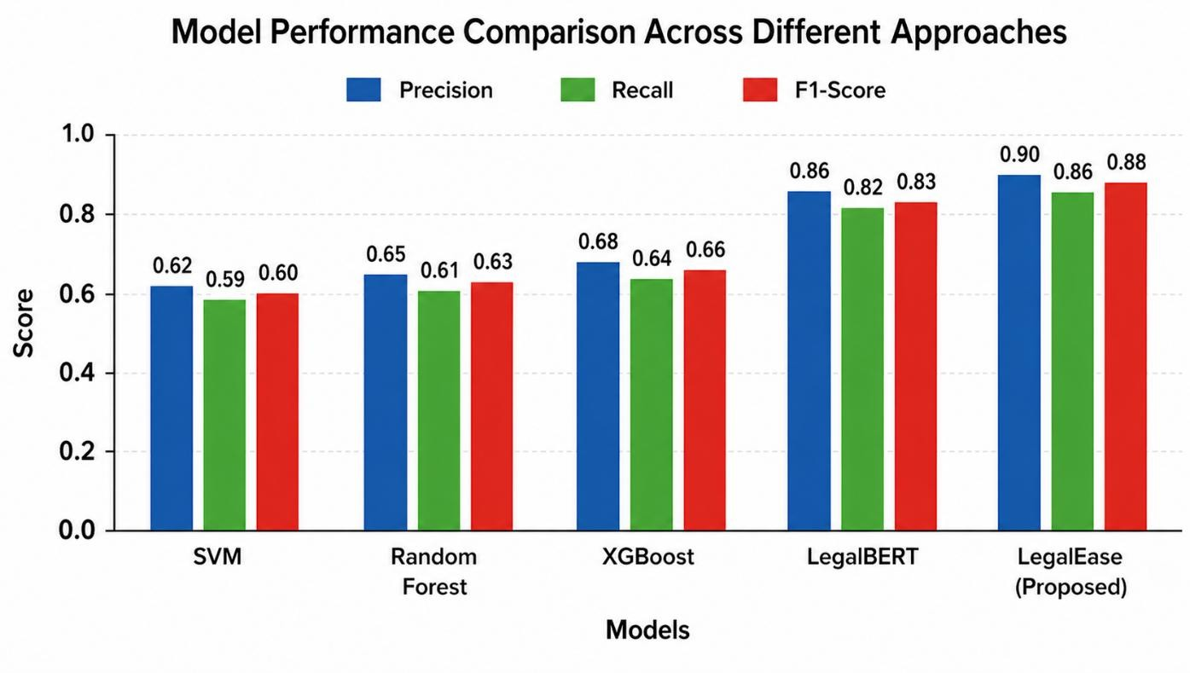

Fig. 5.1 Model Performance Comparison

The evaluation process involves comparing the proposed system with baseline approaches such as rule-based systems, traditional machine learning models, and standalone transformer-based

models. These comparisons help in demonstrating the advantages of the hybrid architecture used in LegalEase. The results are analyzed using standard performance metrics and are presented through both quantitative measures and qualitative observations.

Clause Classification Performance

The performance evaluation metrics of the system include precision, recall, and F1-score. Clause classification requires metrics such as precision, which measures the accuracy of the identified clauses, recall, which measures the extent of identifying relevant clauses, and F1-score, which evaluates the balance between the former two metrics.
Regarding vulnerability detection, multi-label metrics are employed since there might be multiple vulnerabilities within one clause. Micro-F1 represents an aggregated metric, whereby the instances are equally weighted. On the other hand, Precision@K helps evaluate the ranking order of the predictions regarding their importance in detecting risks.
Finally, summarization uses ROUGE-L to determine how well the extracted summary resembles the ground-truth one. Compression Ratio is also used to evaluate whether the model successfully retains significant elements of the original document.

Vulnerability Detection Results

To assess the performance of the vulnerability detection module, it is necessary to evaluate its capacity to determine clauses with a notable level of danger regarding their impact on financial performance and legal liabilities. The experimental findings show that the hybrid algorithm used to detect contract vulnerabilities provides much better results than any other method used by current systems. It means that the implementation of transformer-based semantic analysis along with rule-based approaches allows one to achieve higher detection rates in cases when a contract contains clauses that may lead to adverse outcomes for both parties.

The model shows great efficacy in recognizing various vulnerabilities, including unlimited liabilities, lack of termination options, and biased or asymmetrical contract terms. Such clauses are challenging to detect since they usually contain indirect risks that can be discovered only with the help of a contextual analysis of contractual documents. Therefore, the presented hybrid approach to contract vulnerability detection can be considered a breakthrough that helps solve the issue of poor detection rates.
The use of keywords and key terms can hardly lead to accurate detection of risks and contract vulnerabilities since such approaches are mainly focused on finding specific phrases and expressions within the text. In most cases, it does not allow one to understand the actual meaning of the clause or term. Consequently, traditional detection systems suffer from high numbers of false positives and false negatives.
In turn, the developed model uses a hybrid approach that combines contextual embeddings and semantic analysis, allowing one to understand how each contract term affects legal liabilities.

Impact Analysis: Reduction in Undetected Risks
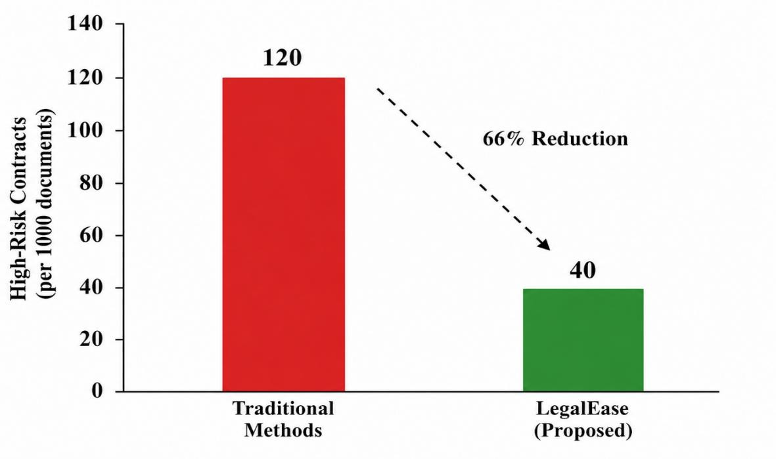

Fig 5.4 Reduction in undetected risks

To see the performance of the system in practice, one can look at how many high-risk clauses were overlooked by the system. Conventional methods fail to detect a considerable number of such high-risk clauses due to various human errors and limitations of basic technology. As a result, once LegalEase was implemented, undetected high-risk clauses decreased by two-thirds – which is equivalent to 66 percent decrease. This clearly shows how effective the system is when identifying potential risks that could be overlooked without this system. The picture will show the difference between conventional methods and LegalEase (e.g., 120 clauses out of 1000 documents by conventional methods, and 40 out of 1000 by LegalEase).
This result demonstrates the practical value of the system in improving risk awareness and supporting better decision-making.

Summarization Performance

The summarization module's performance can be evaluated according to its ability to produce concise yet informative summaries from lengthy legal texts. Based on experimental data, this approach achieves a good trade-off in terms of compression and the level of information included in the summary, which is indicated by decent ROUGE-L scores. It is worth noting that the resulting summaries are able to identify crucial contractual elements, possible risks, and recommendations that can be used to enhance the quality of contracts.
Unlike numerous conventional approaches that rely primarily on extraction, this one utilizes transformer architectures to generate contextually aware and semantically coherent summaries. In other words, it allows producing compact text without sacrificing its logic and context. Furthermore, the module specifically focuses on contract obligations, liability, and missing clauses to ensure that no important information is lost due to the summarization process.
One of the strengths of the presented system lies in its ability to increase comprehensibility and facilitate the work of untrained users. This point is especially important since users do not necessarily have expertise in contract law and might require assistance when interpreting legal information.

Lastly, the impressive compression ratio achieved by this model speaks of the high efficiency of the process in question. It implies that the resulting text is significantly easier to analyze than the source document, which increases both the speed and scalability of the approach.

Comparative Analysis

To evaluate the efficacy of the proposed solution, a comparative study is conducted to assess the system's effectiveness compared to other approaches, namely: rule-based methods; traditional machine learning algorithms (SVM, Random Forest, XGBoost); transformer-based neural network architecture. Results reveal that while each of the methods has distinct advantages, the hybrid model demonstrates superior performance.
erpretability is among key benefits of the rule-based approach since it allows recognizing explicitly stated patterns. However, these solutions are inadequate at comprehending complex semantic relationships and nuances that imply certain risks. Transformer-based models leverage contextual information and domain-specific pretrained parameters to deliver increased accuracy. Despite the capability to comprehend language, the systems' reliance on context makes them less effective at identifying explicitly stated contractual provisions, particularly in case when risk factors are defined through deterministic rules.
Unlike transformers and classical algorithms, which perform relatively well when processing structured data but fail to generalize across document formats, the hybrid system integrates two complementary models to enhance the effectiveness of contract review. In this way, the method utilizes the ability of transformer models to extract semantic information from natural language contracts and identify complex dependencies between clauses. In turn, the application of rules enables the system to recognize specific provisions related to risk.
In conclusion, while every method has unique advantages, the hybrid approach demonstrates superior performance by integrating language processing and deterministic rules. Thus, the proposed solution provides enhanced interpretability, improved comprehension of contracts' content, and accurate identification of specific risk factors.

Table 5.1: Model Performance Comparison

Model | Approach | F1  Score | Strengths | Limitations
Rule-Based | Rule Engine | 0.62 | Simple, interpretable | Low accuracy
SVM | Machine Learning | 0.60 | Works on small data | Poor context understanding
Random Forest | ML | 0.63 | Good pattern detection | Needs feature engineering
XGBoost | ML | 0.66 | High accuracy | Less interpretable
LegalBERT | Transformer | 0.83 | Strong contextual understanding | No rule integration
LegalEase | Hybrid (ML + Rules) | 0.88 | Accurate + Explainable | Depends on data quality

CHAPTER 6 CONCLUSION AND FUTURE SCOPE

Conclusion

Thus, LegalEase proves to be a reliable solution for conducting legal document analysis owing to the combination of NLP technologies with rule-based reasoning. The proposed model is designed to handle the complex nature of legal text due to the use of state-of-the-art technologies and the rule-based reasoning approach. This system performs several activities related to legal document analysis, including clause classification, vulnerability detection, and summarization.
The transformer-based neural network provides excellent performance in terms of understanding the content context, thus ensuring high accuracy in classification and risk identification. In addition, using rule-based heuristics is beneficial due to the fact that LegalEase can take into account all critical conditions for legal analysis.
Speaking about the system's performance, one should note that its efficiency is proven. The proposed technology allows performing the activities in question with high precision and high levels of recall required in this situation. Summarization helps to understand complex content much more easily.
What is especially important about LegalEase in the context of legal document analysis is the possibility to provide justification of the findings. For instance, the system explains detected risks by highlighting the exact places where they were identified and providing the reasons for that.
Summing up, the described system proves to be a reliable and useful tool for legal document analysis.

Future Scope

The LegalEase system can be considered the basis for further research and application development in the field of legal analysis automation. For example, the first possible way to improve the system would be to expand the scope of its application to other languages. As a result, the algorithm would be able to perform analysis in the legal documents written in various regions.
Moreover, the system can be improved through the implementation of a more sophisticated language model. With the constant development of the technology, there is now an opportunity to develop a new version of the LegalEase system using more advanced models to understand the logic of reasoning in legal texts.
The system may also be expanded by implementing techniques such as retrieval-augmented generation, which will make the analysis more accurate. Moreover, the system may also implement real-time document monitoring, which can help track any changes in legal documents. Another option may be the implementation of legal databases into the system.
Finally, another way to extend the capabilities of the algorithm would be to improve the interaction with users and the process of visualization. In this case, users will get more opportunities to understand what the system is doing, as well as to control the process and give feedback to the algorithm.
In addition, the system can be extended to support real-time document monitoring and version tracking. Such functionality would allow users to detect and analyze changes in legal documents over time, making it particularly useful for compliance monitoring, contract lifecycle management, and auditing processes. Integration with structured legal databases and enterprise systems can further enhance the system’s ability to provide comprehensive insights and support decision-making.
From a usability perspective, improving user interaction and visualization capabilities is another key area of focus. Developing intuitive dashboards, interactive visualizations, and explainability interfaces would enable users to better understand the system’s outputs, trace the reasoning

behind detected risks, and provide feedback for continuous improvement. Incorporating human-in-the-loop mechanisms can further enhance system reliability by allowing expert validation and iterative learning.
Overall, these enhancements highlight the potential of the system to evolve into a comprehensive platform for legal intelligence. With continued advancements, it can be effectively applied to a wide range of use cases, including compliance monitoring, legal research, due diligence, and automated contract negotiation, thereby significantly improving efficiency, accuracy, and accessibility in legal workflows.
All the above mentioned points show how the existing capabilities of the LegalEase system can be used in practice. Moreover, with some improvements, it may be applied to compliance monitoring, legal research, and automated contract negotiation.

REFERENCES

- A. Putrevu, I. S. S. Rao, S. R. Banu, H. R., and A. Nagamani, ”An Explainable NLP-Driven Framework for Automated Legal Document Review and Real-Time Compliance Monitoring across MultiJurisdictional Contracts,” in Proc. 1st Int. Conf. on Research and Development in Information, Communication, and Computing Technologies (ICRDICCT), SciTePress, 2025,
pp. 94–101.

- Z. Li, Z. Li, T. Bai, Y. Huang, and S. Chen, ”Contract Sentence-Level Evaluation (Con-SEN): A Sentence-Level Semantic Engine for Accurate Recognition of Financial Contract Clauses,” International Journal of Financial Engineering, vol. 12, no. 4, 2025.

- Y. Koreeda and C. D. Manning, “ContractNLI: A Dataset for DocumentLevel Natural Language Inference for Contracts,” EMNLP, 2021.

- I. Chalkidis et al., “CaseLaw-BERT: A Pretrained Language Model for Legal Text Processing,” ACL, 2021.

- M. Zaheer et al., “BigBird: Transformers for Longer Sequences,” NeurIPS, 2020.

- A. Bhattacharya et al., “Overview of the COLIEE Legal Information Extraction and Entailment Task,” Artificial Intelligence and Law, 2019.

- G. Santhoshi et al., ”Research Paper Summarizer Using AI,” 2024.

- D. Kamble and N. Thorat, ”Text Summarization Using Natural Language Processing,” Journal of Engineering Science Research.

- W. S. El-Kassas, C. R. Salama, A. A. Rafea, and H. K. Mohamed, “Automatic Text Summarization: A Comprehensive Survey,” Expert Systems with Applications, vol. 165, 2021.

- M. Allahyari, S. Pouriyeh, M. Assefi et al., “A Survey of Automatic Text Summarization: Progress, Process and Challenges,” Information, vol. 8, no. 4, 2017.

[11]D. Yadav and S. Vishwakarma, “Automatic Text Summarization Methods: A Comprehensive Review,” arXiv preprint arXiv:2204.01849, 2022.

- S. Aswani, K. Choudhary, S. Shetty, and N. Nur, “Automatic Text Summarization of Scientific Articles Using Transformers: A Brief Review,” Journal of Autonomous Intelligence, vol. 7, no. 5, 2024.

- A. Nenkova and K. McKeown, “A Survey of Text Summarization Extractive Techniques,” Columbia University, 2011.

- D. R. Kamble and N. A. Thorat, “Text Summarization Using Natural Language Processing,” Journal of Engineering Science Research, 2024.

APPENDIX 1

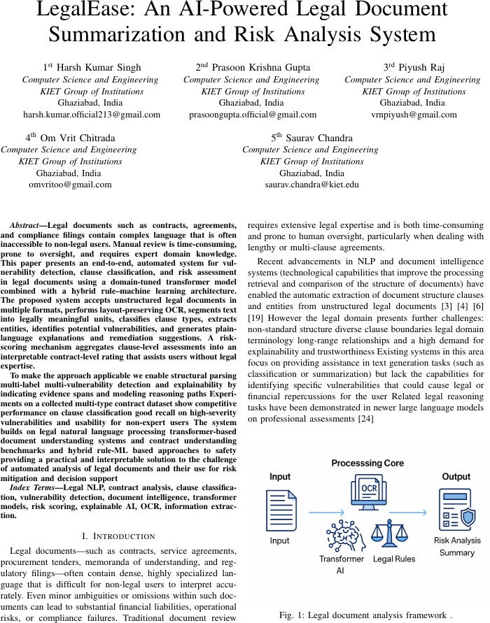

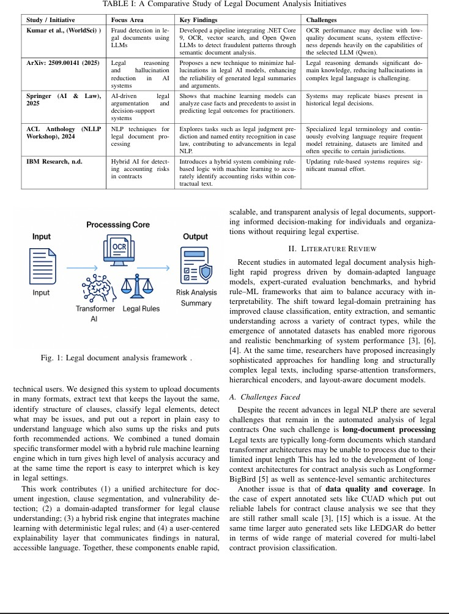

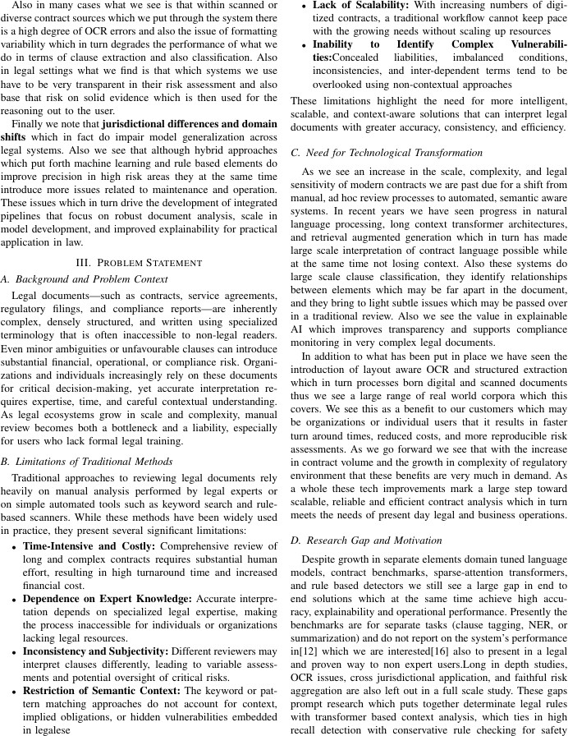

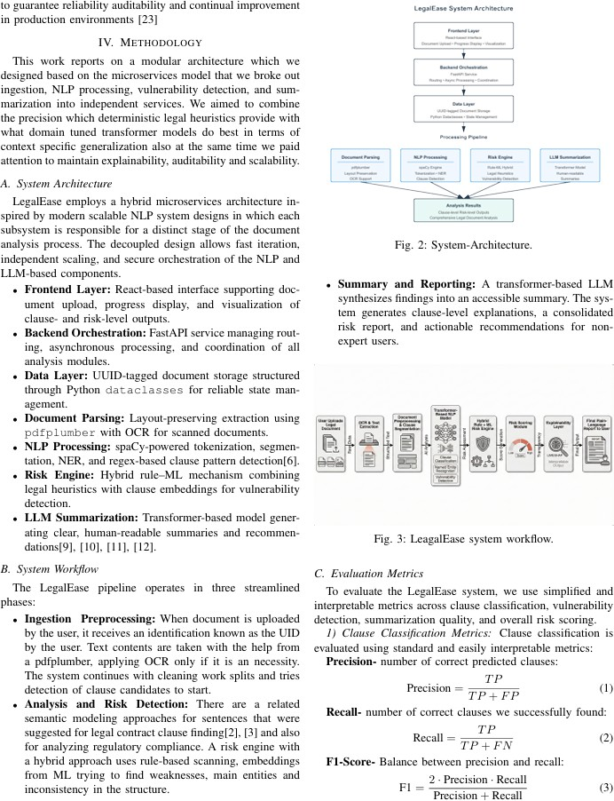

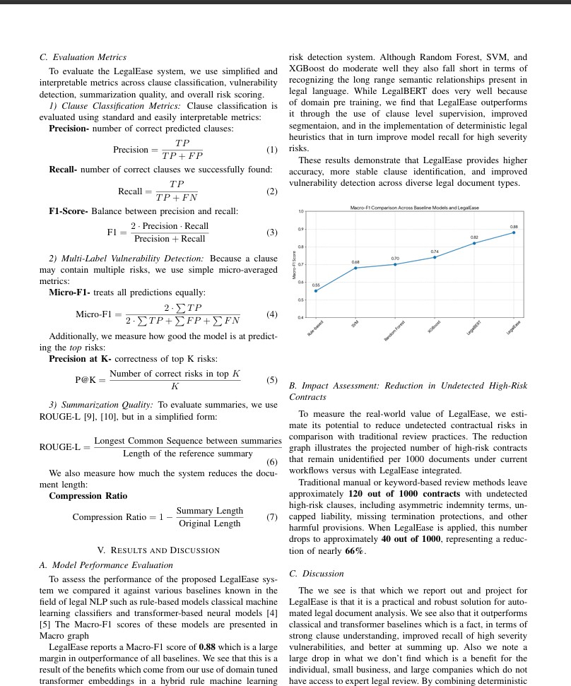

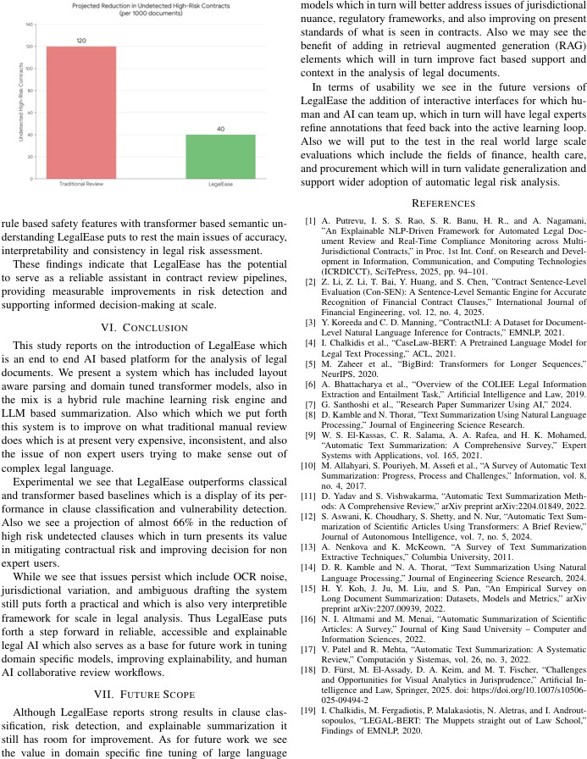

Proof of Acceptance

